TITLE OF THE PAPER (14pt, bold)
First AUTHOR¹, Second AUTHOR², Third AUTHOR³, … (FullGivenName SURNAME, 11pt, bold)
- Affiliation, Address, City, Country, E-mail: first.author@univ.com; (10pt, regular)
- …
- …

Introduction
Please use this template to prepare the two-page extended abstract for the 38th Danubia-Adria Symposium on Advances in Experimental Mechanics, which will take place in Poros, Greece, between September 20th-23rd, 2022.
All formatting data is contained in the template, so you can simply insert the text, tables, equations and figures in this file.
Conference proceedings will be published both in printed and in electronic formats. The electronic format will be uploaded on the symposium website
www.38danubia.org
Please respect this format in order to make the editor’s work easier.

Page setup
All text will be formatted with the Page Setup shown in the figures below:
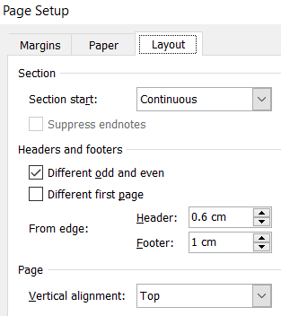
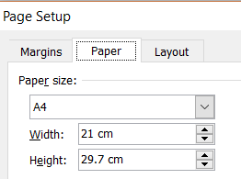
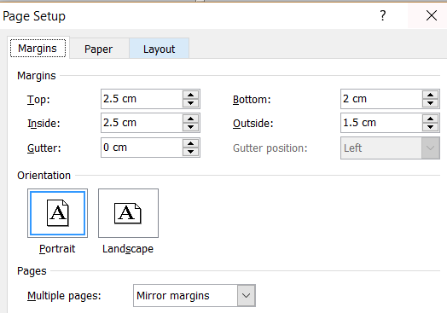

Format of the text
The text should be written with Times New Roman 11pt, justified, single line spacing. First line will be indented with 0.5cm. Paragraphs will have 6pt spacing before.
The title of contribution should be written with 14pt Times New Roman capital font, bold. The authors’ name should be written with Times New Roman 11pt bold with upper-indices for details, and authors’ details (address, e-mail) with 10pt Times New Roman font, all centered.
The section titles will be written with 12pt bold, 12pt spacing before and 3pt spacing after.
Excepting title and authors, all text will be written in two-column format. Each column will have a width of 8cm, with 1cm between columns.
The text throughout the contribution should be structured into the following sections: Introduction, Materials and methodology, Results, Conclusions, Acknowledgements, and References.

Subsections
Subsection titles will be written with Times New Roman, 11pt italic, 6pt spacing before and 3pt spacing after. Each section can be divided into one level of subsections, if necessary.

Figures
Figures should have a width of maximum 8cm and will be addressed in text as Fig. 1, Fig. 2, etc. Legend of the figure should be written below the figure, with Times New Roman 10pt, centered, 6pt spacing before. Only the text “Fig. 1.” is written with bold.
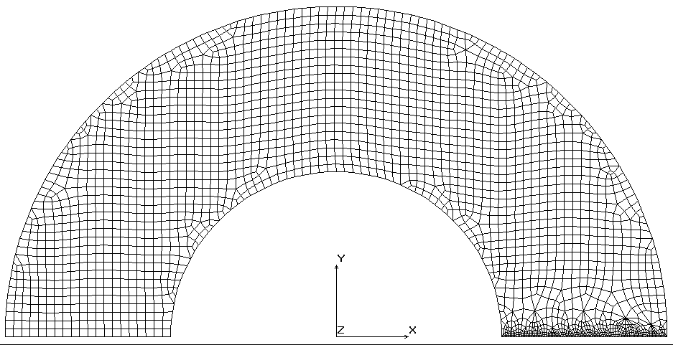
Fig. 1. Figure legend here (10pt, centered).

Tables
Text in the tables will be written with Times New Roman, 10pt. Numbers in the table should be aligned right. If more columns are necessary, height of text can be lowered to 9pt in order to fit in the cells. Legend of the table should be written above the table, with Times New Roman, 10pt, centered. Only the text “Table 1.” is written with bold.
Table 1. Table legend here. (10pt, centered)
Case no. | Force  [N] | Stress  [MPa] | Strain  [%]
1 | 156000 | 156.00 | 0.0742
2 | 242350 | 242.35 | 0.1154

Equations
All equations should be written with Times New Roman, 11pt. They will be centered using tabs and numbered on the right side in rounded brackets.
Equations will be inserted using the equation editor of Microsoft Word or using Math Type and will be addressed in text as Eq. (1).
(1)
(2)

Citations and references
Cited papers, books, websites should be referred in text by the reference number in square brackets, following the Science and Engineering citations style. The references have to be listed in order of appearance and cited as shown in the examples at the end of this template. Format of the reference [1] is for journal paper, reference [2] for conference paper, reference [3] for book and reference [4] for websites.
You can find abbreviations of journals here: http://images.webofknowledge.com/images/help/WOS/A_abrvjt.html

Deadlines
The extended abstracts will be submitted online directly, from the Symposium website: www.38danubia.org according to the instructions

Conclusions
All new contributions of the authors of the paper should be summarized briefly in the concluding remarks.

Acknowledgements
It is possible to write the acknowledgements for the projects and supporting institutions.

References
- Suo, Z., Kuo, C., Barnett, D., Willis, J. Fracture mechanics for piezoelectric ceramics. J Mech Phys Solids, 1992, 40(4), 739–765.
- Johnson, A., Byles, B. Experimental determination of fracture parameters in composites. In Proceedings of the 25th International Conference on Advanced Materials, Barcelona, 6-9 Dec, 2015; Kay, L., Smith, B.B., Eds.; Martel Publishing House, Barcelona, 2015; pp. 123–129.
- Anderson, T. L. Fracture mechanics: fundamentals and applications; CRC Press: Boca Raton, 2017.
- Bone fracture. http://www.nmihi.com/b/bone-fracture.htm. Accessed December 24, 2019.

